

**CIND 820**

Final Report

Student Name: Ryan Boyd

Student Number: 501072988

Date Submitted: 3/28/2022

Project Supervisor: Dr. Ashok Bhowmick

**Introduction and Project Purpose**

This project aims to discriminate unique objects from a LiDAR point cloud dataset which was collected from an aerial aircraft. LiDAR data is commonly used to return very precise elevations of the earth’s surface and is also used to detect objects for self driving vehicles. Point clouds returned by LiDAR sensors do not inherently differentiate anything in the data, they typically simply collect and store the laser pulse return information, which is processed to return some characteristics of the surface below. These characteristics include the height of the surface, the intensity or brightness of the returned pulse, the number of pulses that were returned, for cases where the laser partially hits a surface and continues to travel, scan angle and even r,g,b, in some cases along with some others. This project will investigate whether some clustering algorithms can be used with this data and its attributes to identify objects by using unsupervised machine learning. The ability to identify and count the number of unique features in a scene can be done with aerial imagery, but there are several drawbacks such as the presence of shadow as we will see. Capability to identify unique features with LiDAR could be a useful practice for several reasons including asset management and tracking, scenery reconnaissance, object detection and avoidance (on vehicle mounted devices for example), robot vision, environmental or vegetation growth studies, building development studies among many more. Distinguishing and counting unique objects from the data can also prove to be a useful step in classifying and categorizing the scenery in combination with other methods.

**Research Questions**

“Can unique objects be distinguished from lidar data point clouds using clustering tools?”

**Github Repository**

<https://github.com/rboyd-ryerson/CIND820>

**Existing Research Literature**

There were several research papers on the subject matter, many of which contained more advanced topics which I have not attempted to replicate. The concepts, however, are very similar and I have used many of the ideas in my project. For example, in the paper “AIRBORNE LIDAR FEATURE SELECTION FOR URBAN CLASSIFICATION USING RANDOM FORESTS” by Nesrine Chehata, Li Guo and Clément Mallet, they extracted the ground and off-ground features by differentiating the lowest points, which is similar to the method I have used. I also used the idea for random forests from this paper, to reclassify the ground points to improve the classification. This paper also mentions the use of eigenvalue based feature detection, which I was interested in applying but did not end up pursuing, perhaps in the future I would like to examine this.

The idea of edge detection was also mentioned in the paper “ADAPTIVE BUILDING EDGE DETECTION BY COMBINING LIDAR DATA AND AERIAL IMAGES” by LI Yong, WU Huayi, where they use aerial imagery to detect buildings. I was inspired by this idea to incorporate the imagery, however I did not achieve great results due to certain limitations in the data, time and my own knowledge.

In the paper titled “SEMI-AUTOMATED APPROACH FOR MAPPING URBAN TREES FROM INTEGRATED AERIAL LiDAR POINT CLOUD AND DIGITAL IMAGERY DATASETS” by Dogon-yaro, M. & Ac, P & Kumar, Pankaj & Rahman, Alias & Buyuksalih, G., they also used imagery in combination with lidar to attempt to classify vegetation. The NDVI was a calculation I considered to extract the vegetation, but needed the NIR data which was not provided, this paper also explored the negative drawbacks of shadows in the imagery.

Several other papers included useful information:

“Machine Learning Algorithms and Applications for Lidar, Images, and Unstructured Data” by Biswas Parajul – focuses on road segmentation and covers more advanced algorithms.

“A Knowledge-based Approach to Urban Feature Classification Using Aerial Imagery with Lidar Data” by Ming-Jer Huang, Shiahn-Wern Shyue, Liang-Hwei Lee, and Chih-Chung Kao gave me the idea to use rule-based criteria to attempt to define the classes, but this proved to make things too complicated and not enough data was available to me to implement further.

“AUTOMATED BUILDING DETECTION USING RANSAC FROM CLASSIFIED LIDAR POINT CLOUD DATA” by D.L. Bool, L.C. Mabaquiao, M.E. Tupas and J.L. Fabila as well as "AERIAL POINT CLOUD CLASSIFICATION WITH DEEP LEARNING AND MACHINE LEARNING ALGORITHMS” by E. Özdemir, F. Remondino and A. Golkar were some other interesting classification research studies which used several machine learning/deep learning techniques such as CNN, RNN and RANSAC, which I was not familiar with and did not attempt to replicate, though the information within the study was still valuable for insight.

**Data**

The lidar dataset was acquired from the City of Vancouver’s Open Data Portal as an LAS filetype. It contained 2 million points from an area of approximately sqft. There were **20,975,490** data points in total. These data points were read into a pandas dataframe using the ‘laspy’ library.

The dataset was “clipped” to a smaller containment area of interest by querying the coordinates to within the desired extent. After clipping to the area of interest, there were **856,130** points in total.

The horizontal projection coordinate system of the data is NAD83 UTM10 which represents the coordinates as meters from the equator for the latitude (Y) and meters from the Central Meridian in Greenwich for the longitude (Y).

An aerial orthophoto of the same area was also obtained from the City of Vancouver’s open data portal site to extract the R,G,B values and to visualize the area as a reference.

The data contained the following attributes:

|  |  |  |
| --- | --- | --- |
| Field | Description | Datatype |
| X | X Longitude Coordinate | Double |
| Y | Y Latitude Coordinate | Double |
| Z | Z Elevation | Double |
| Intensity | Strength of returned laser pulse | Integer |
| Return Number | Return number of the given point | Integer |
| Total Number of Returns | All returns generated from the given pulse | Integer |
| Classification | Provided classification (ground,unclassified) | Integer |

Dataset description:

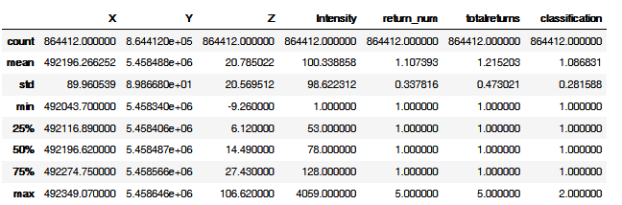

**Project Goal/Theory**

The intention of this project is to cluster the points into unique features that are essentially distinguishable objects based on the spatial location, height and surface reflectance(intensity).

**Methodology - Preprocessing**

*Data loaded and examined*

The first step was to import the dataset and store it into a pandas dataframe to be visualized in a table. Since the data contained coordinates, it could also easily be visualized on a graph which accurately represents the real world. Outlines of features can already be seen in the plots because of the density of points surrounding objects with a significant vertical surface.

Data frame sample:

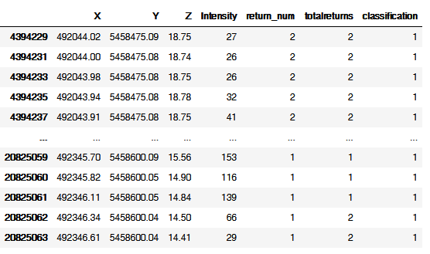

Dataset plot:

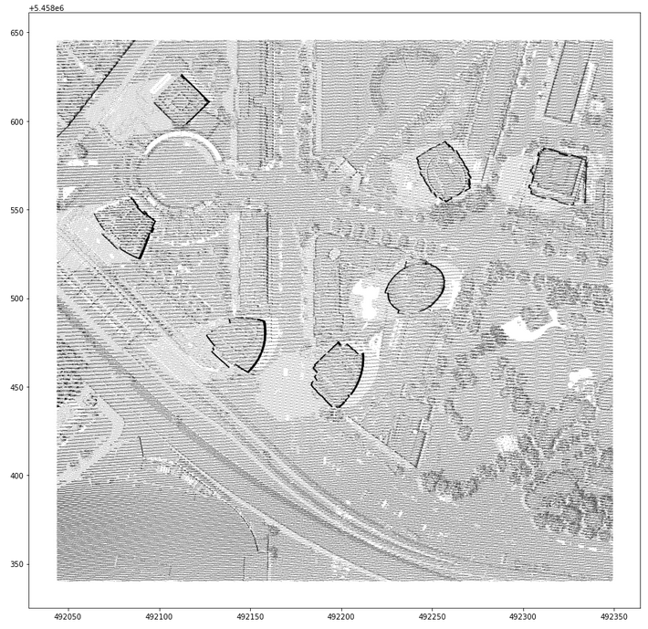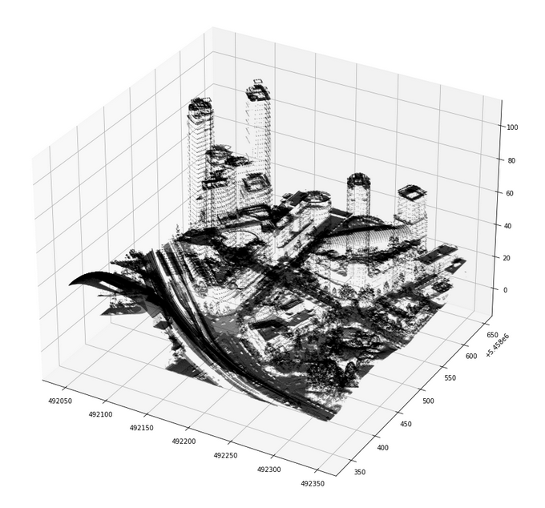

X and Y values plotted X, Y and Z values plotted

*Exploratory analysis*

The data was inspected to get an idea of what the data looked like, see the distributions and look for outliers.

|  |  |
| --- | --- |
| X |  |
| Y |  |
| Z |  |
| Intensity |  |
| Return Number |  |
| Total Returns |  |

*Cleaning and manipulation*

Some of the data needed to be processed before running the models. The intensity values were concentrated at the lower end where very few values were present in the high end. The high values were considered to be outliers and removed to even out the distribution to below 300.

Intensity values were concentrated at lower end and very sparse at the high end, for some reason the maximum intensity was 4059 even though the mean was 100 and the 75th percentile was 128, meaning the majority of values were well below this.

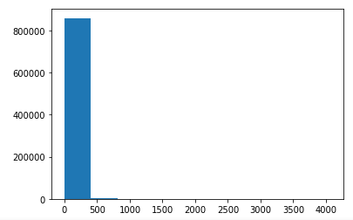 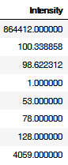

Intensity values were filtered to remove high outliers for a more even distribution, because this would likely skew the results if too many of the values are very low, leading to improper weighting. The fixed values below:

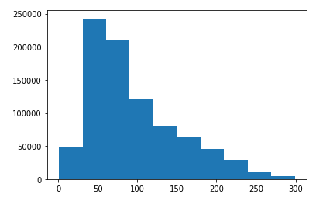

*Relative height to ground attribute creation*

The Z value provided in the dataset provides an absolute height of the objects, however it would be better to use a relative height to the ground. A “DEM” image was provided with the dataset which is an image of the ground where each pixel represents the elevation. The value of each pixel can be subtracted from the Z value of any point at it’s location to obtain the “Height” value which is used in the models instead. To align the data to the image, I rescaled the data to match the size of the image, and used the python PIL library to extract the pixel value from the rescaled coordinates of the image. This method was also used to extract the R,G,B values from an orthophoto as described below. The formula below describes how the values are scaled, this works because the coordinates are scales to between 0 and 1, then multiplied by the image size. This is done for each of the X coordinates, and then again on the Y coordinates.



The pixel value from the image is recorded for each lidar point. The height is then calculated by subtracting the pixel value from the original Z elevation value.

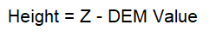

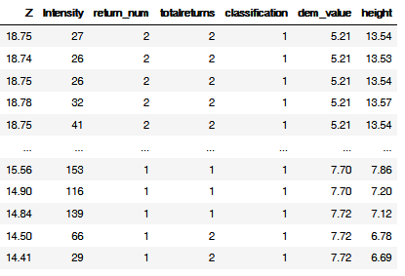

*RGB Imagery Value extraction*

An aerial photograph was also obtained and imported into the dataset. By scaling the data to fit the image, in a similar way as the DEM, the RGB values of the lidar points were obtained. Due to the shadows obstructing much of the image, difference in age from data collection by ~ 1 year and that the values did not greatly improve the results, these values were not used to train the model. I looked into altering the values to remove the effect of the shadows but this proved to be time consuming and I did not pursue it much further. The image however will be used to provide a visualization of the clusters to identify and assess the detected features.



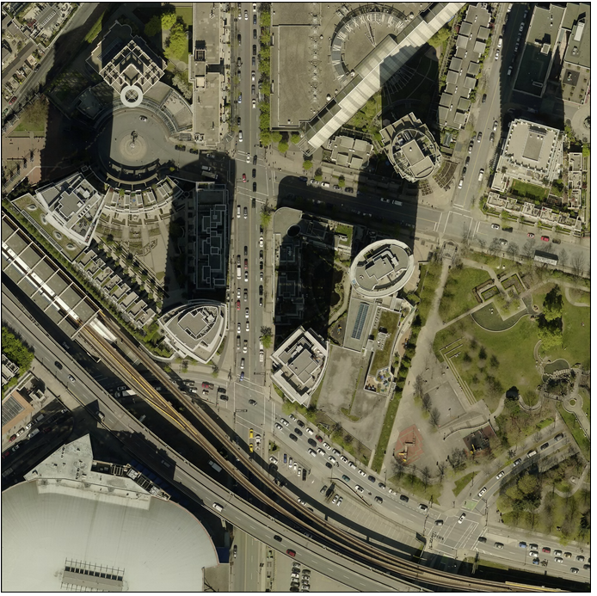 

*Data Normalization*

The data was then normalized on a scale from 0 to 1 to balance the weighting of the attributes in the models. The formula used for this normalization is the following:

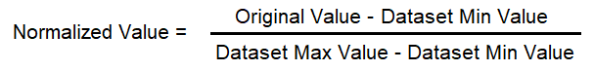

Sample of values after normalization, and data plotted showing new scale from 0 to 1:

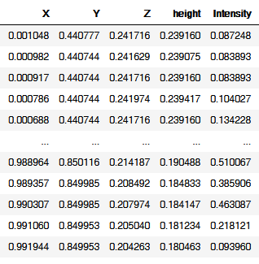 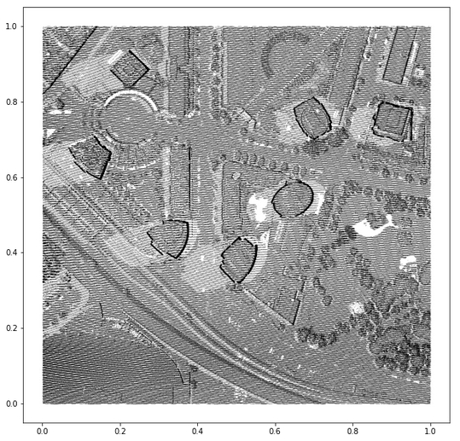

**Methodology – Machine Learning**

*Supervised ground classification*

The data was provided partially classified for the ground points, however upon inspection it did not appear to be complete since most of the areas labeled ground, were still appearing in the unclassified data. I decided to use the provided ground classified points as labels and train a supervised classifier to attempt to classify additional ground points that were still unclassified.

Before: 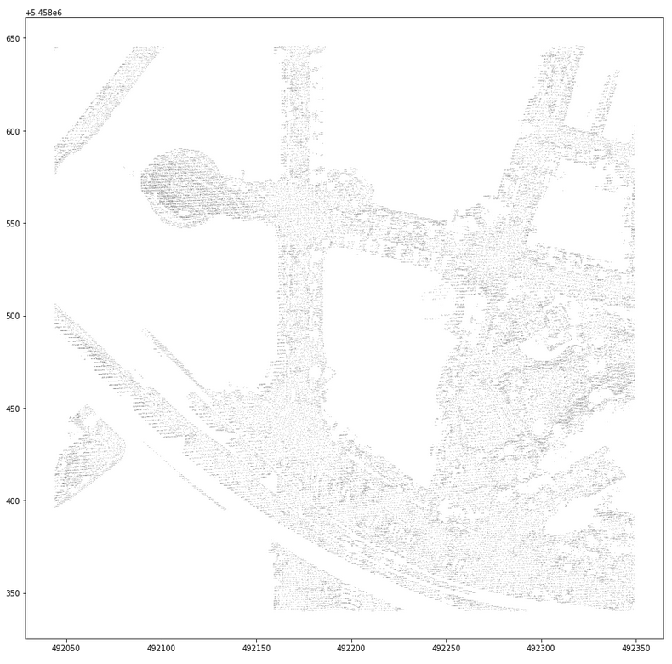 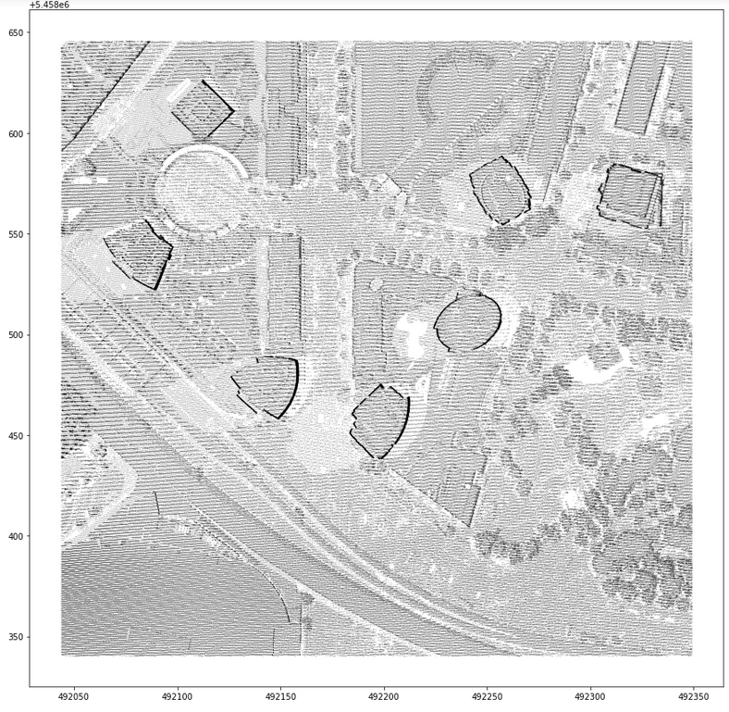

Ground points (as provided) Unclassified points

Data as provided and classified as ground points shown on the left and unclassified points on the right, there is not a clear distinction where the ground is in the image on the right. If this area was ground, it should not remain unclassified and should not still be visible in the unclassified data.

A random forest classifier was used to classify the ground from the unclassified data using the provided ground points as labels.

The data was split into training and test sets and the data was fit to the model using the parameters: intensity, height, return count and return number as inputs to the model.

|  |  |  |
| --- | --- | --- |
|  | Predicted Non-Ground | Predicted Ground |
| Original Non-Ground | 554640 | 226462 (new) |
| Original Ground | 237 | 74791 |

The accuracy score from the model was 0.734 using the test set. The model was then used to predict the ground points for entire dataset. As provided, there were **75,028** points classified as ground in the initial dataset. After my classification there were **301,253** points classified as ground.

Confusion Matrix:

Full dataset accuracy: 554640 + 74791 / 856,130 = 0.735

After: 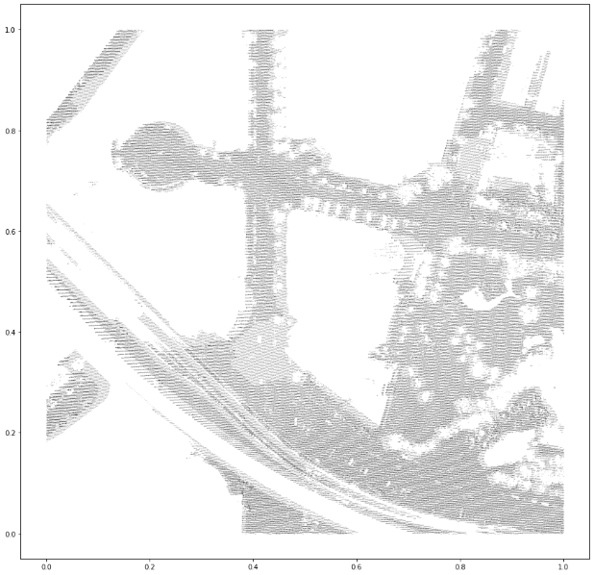 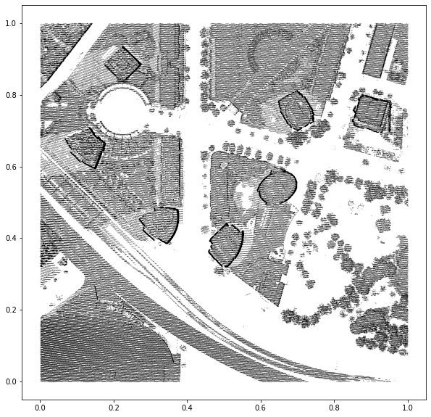

Ground points (newly classified) Non-Ground (unclassified)

The new datasets now show clear distinction between the ground points and non ground points. The unclassified points now will be used to attempt to identify additional objects in the data. There is a total of **554,877** non-ground points remaining to be classified/clustered.

*K-means clustering for initial classification*

The first clustering step was to cluster based on features that were not related to the X,Y locations of the objects. The features used to train this model were the height, intensity, and the return counts. This will attempt to classify the points into classes that will then be used in the spatial clustering as an additional input. The K-means algorithm was used to perform this. In order to determine the number of clusters, the models were evaluated using the Calinski-Harabsz score. This metric, also known as the “Variance Ratio Criterion”, represents the ratio of the distance within points of each cluster, and the distance between the clusters themselves. The higher the value for this metric, the better the performance of the model. Evaluating using this metric resulted in the optimal number of clusters to be 3, which yielded the highest score.

All 554,877 points were clustered into 3 unique clusters with a Calinki-Harabsz score of 771,834. The next best C-H score would have been 731,768 for 4 clusters and 676,329 for 5 clusters. (Since the higher the score, the better the performance of the model, 3 was chosen).

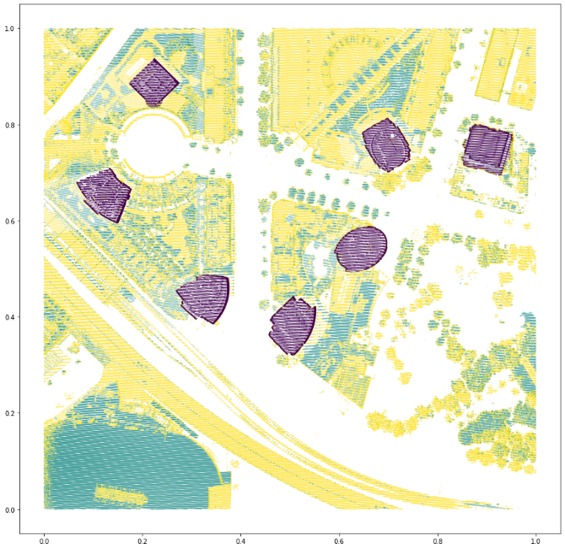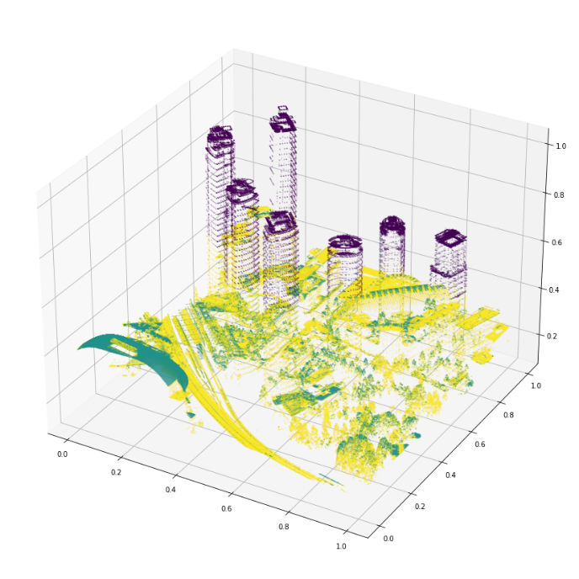

*Spatial/Distance Clustering for unique object discrimination*

The final and main step was to attempt to cluster the points by their X,Y location and the cluster number or the class returned from the previous K-means step. This will group together the points by proximity and by type in order to cluster the points that are likely part of the same object.

The DBSCAN algorithm is used for this, with feature inputs being: X, Y, and the k-means cluster id which is now named k_cluster. The output from this model, will return unique features as a cluster id which will be named db_cluster. This algorithm will only cluster points that are spatially contiguous since X and Y coordinates are used, and of similar type, from the k_cluster.

The model input parameter “eps” refers to the max distance for a point to be considered as part of a cluster, proved to be the most important parameter for this model and affected the results significantly. If too large, the clusters would include too many points and become larger than seemed reasonable, if “eps” was too small, the clusters would be too small, and too few of the points would end up being clustered.

In order to determine the optimal value for the “eps” parameter value, the input feature array is first graphed using the NearestNeighbours algorithm to obtain this figure:

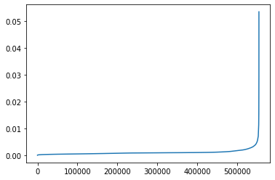This shows the average spacing of all the points of the input features. The location on the Y axis where the elbow or inflection point occurs should provide the best value for the eps parameter because we want a balanced measure of distances to points within each cluster. There is some play in the value as we will see which does influence the final results, such as the size and number of clusters returned. The optimal value of “eps” was found to be between 0.005 and 0.009.

Another parameter of the algorithm is “min_samples”, which is the minimum number of points required for a cluster to form, was set to 50. This value is less significant but can limit the number of small clusters that are created if desired to only locate the larger clusters.

The DBSCAN algorithm returned a total of 585 clusters out of a total of 419,558 points. While the Calinski-Harabsz score can be used with this model, it is less informative for this purpose. Another metric called the silhouette score was used to evaluate this model. This metric evaluates the overlap of clusters to determine the performance. The value returned on a sample of the data was -0.3. The values from this metric range from -1 to 1 where -1 means there is significant overlap in the clusters and 1 where there is not significant overlap. A value of -0.30 suggests there is overlap in the clusters which I believe is normal for this data and problem. I was unable to improve the performance of the model without sacrificing the intended results.

*Performance Measures*

Two commonly used performance metrics used for unsupervised learning are the Calinski-Harabsz score (or the Variance Ratio Criterion) and the silhouette score. The Calinski-Harabsz score is more useful when comparing between models to tune the parameters, however, and not for assessing overall accuracy in general. For the model in question, this score ended up increasing as the “eps” value increased, which was not ideal since an optimal value of “eps” was limited to the range determined above, so this metric would not work very well for this purpose. The model did not perform very well with the silhouette score with around -0.3, indicating there was overlap in the clusters as mentioned above. It is difficult to say whether this metric was appropriate for this task. I believe some overlap is expected in this scenario, therefore the silhouette score may be unfit to use to assess the model. For example, it is possible that two unique objects were identified separately due to the intensity value but are still connected as one object, such as a window pane on a roof, these types of features would result in a bad silhouette score since the 2 clusters would overlap with each other if one cluster is inside of the other. The Calinski-Harabsz score was successful in assessing performance of the K-means classifier above. Also, the confusion matrix for the supervised ground classification to assess that performance is provided in the above section as well. These represent all the performance metrics that were used or considered in this research project.

**Results**

The final process returned a total of 585 clusters of various sizes as shown below, these are visualized below by implementing a convex hull shape around all of the points and coloured to differentiate them from the perspective of the aerial photo.

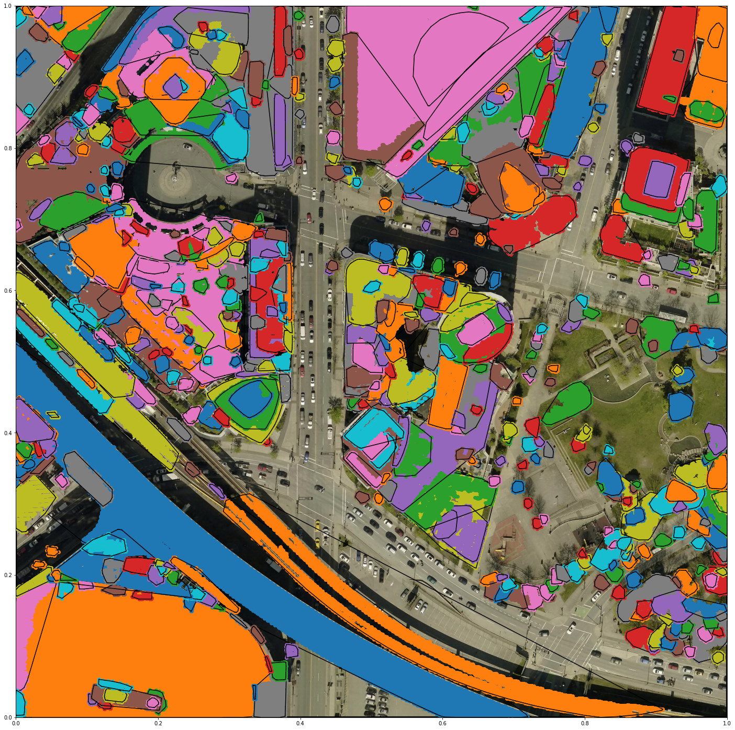

To improve the visualization, the clusters were split into 3 groups based on the size of the clusters.

Small Features (<500 points per cluster): 468 features

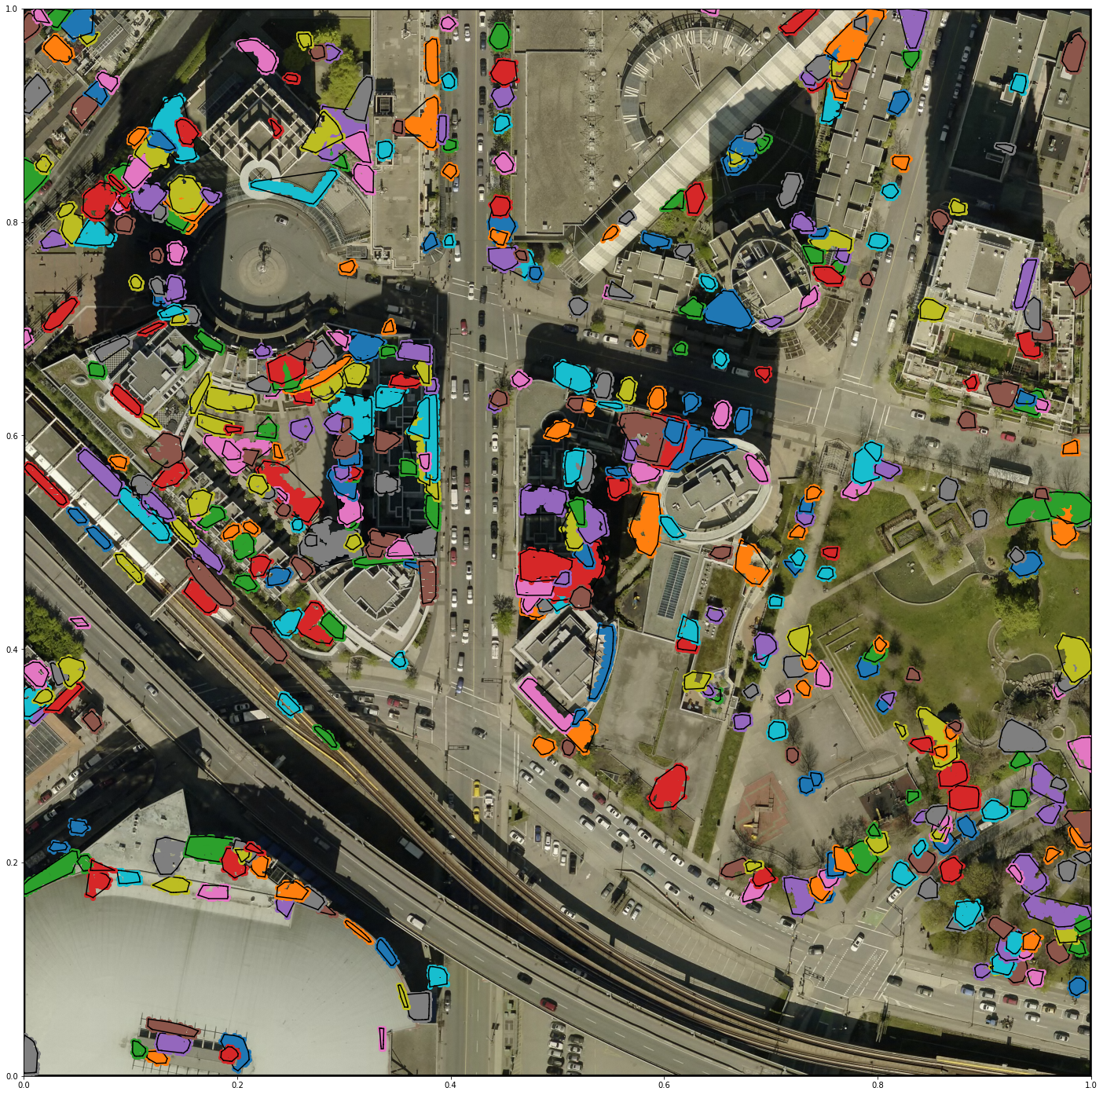

Among these features, there are apparent trees, balconies, rooftop features, windows, among some others.

Medium Features (Between 500 and 2500 points per cluster): 88 features

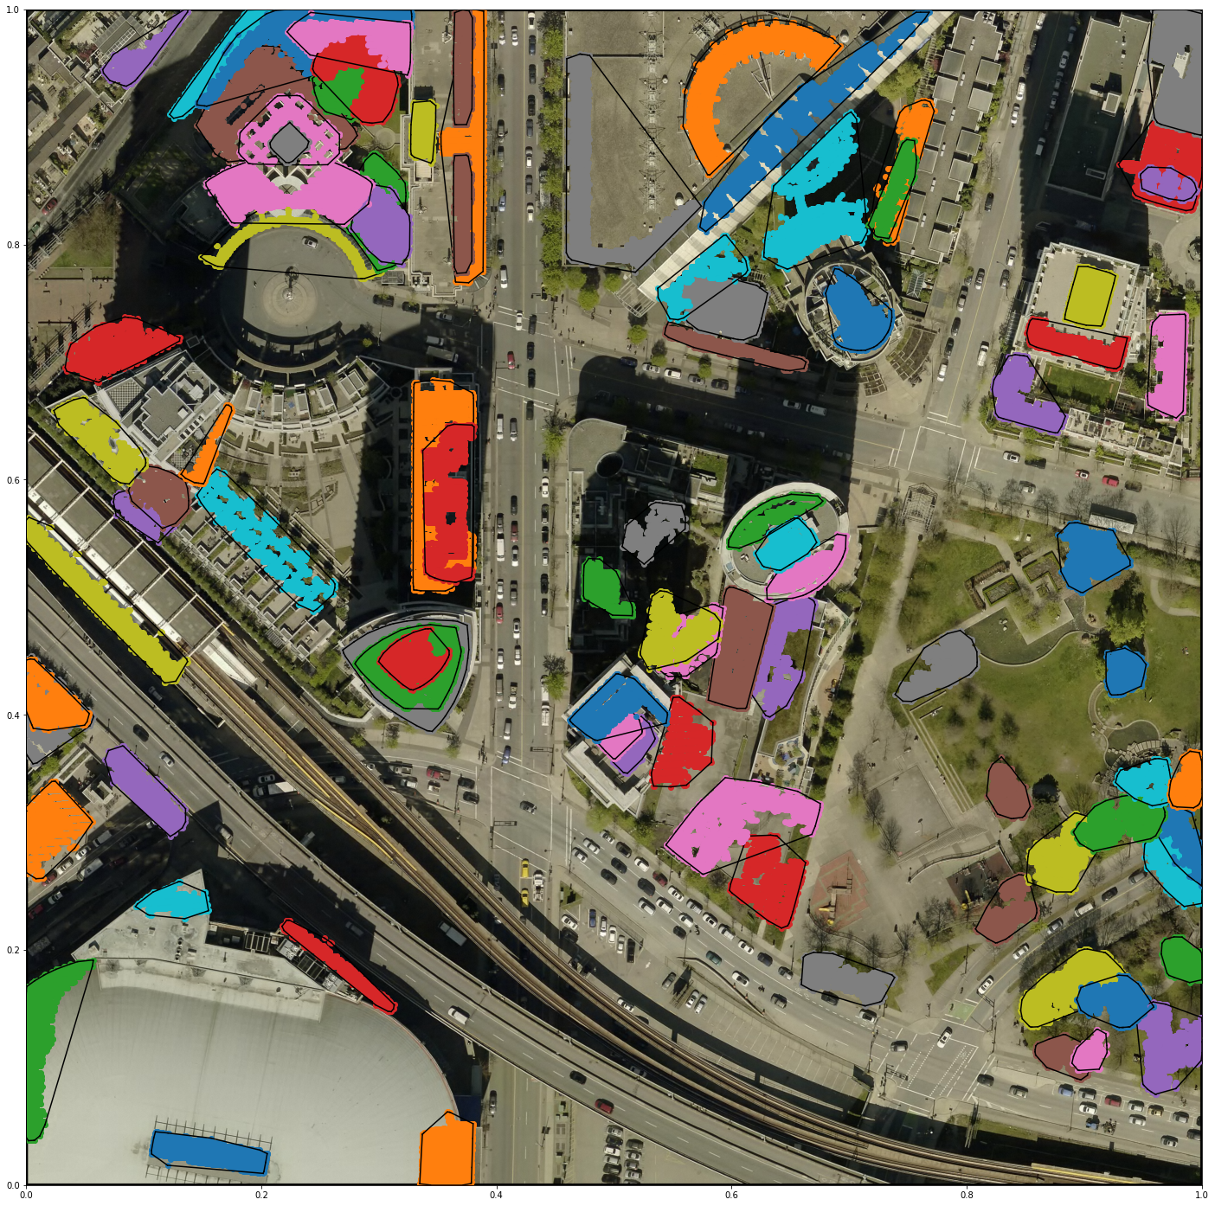

Among these features are building footprints, apartments, larger tree canopies, larger rooftop features, balconies, raised patios and platforms.

Large (Over 2500 points per cluster): 28 features

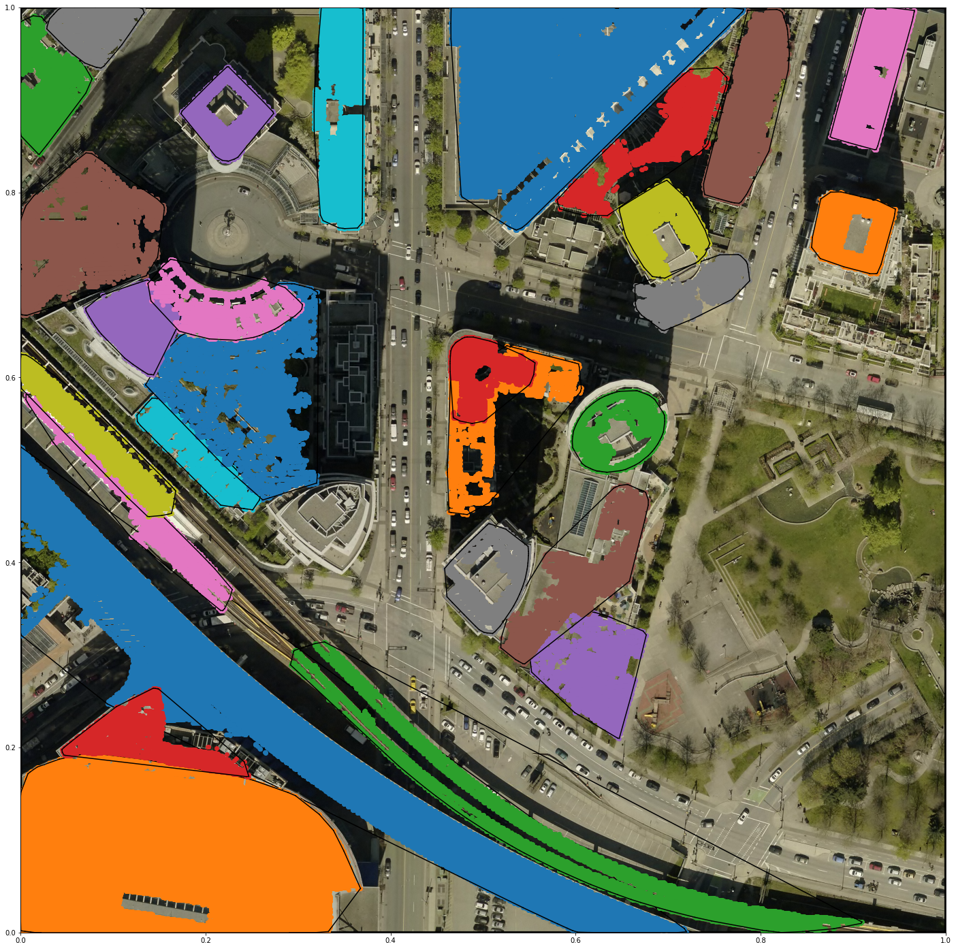

Among these features appear to be raised roadway and viaduct, raised rail tracks, larger building footprints and rooftop features.

All features visualized with classified ground in black:

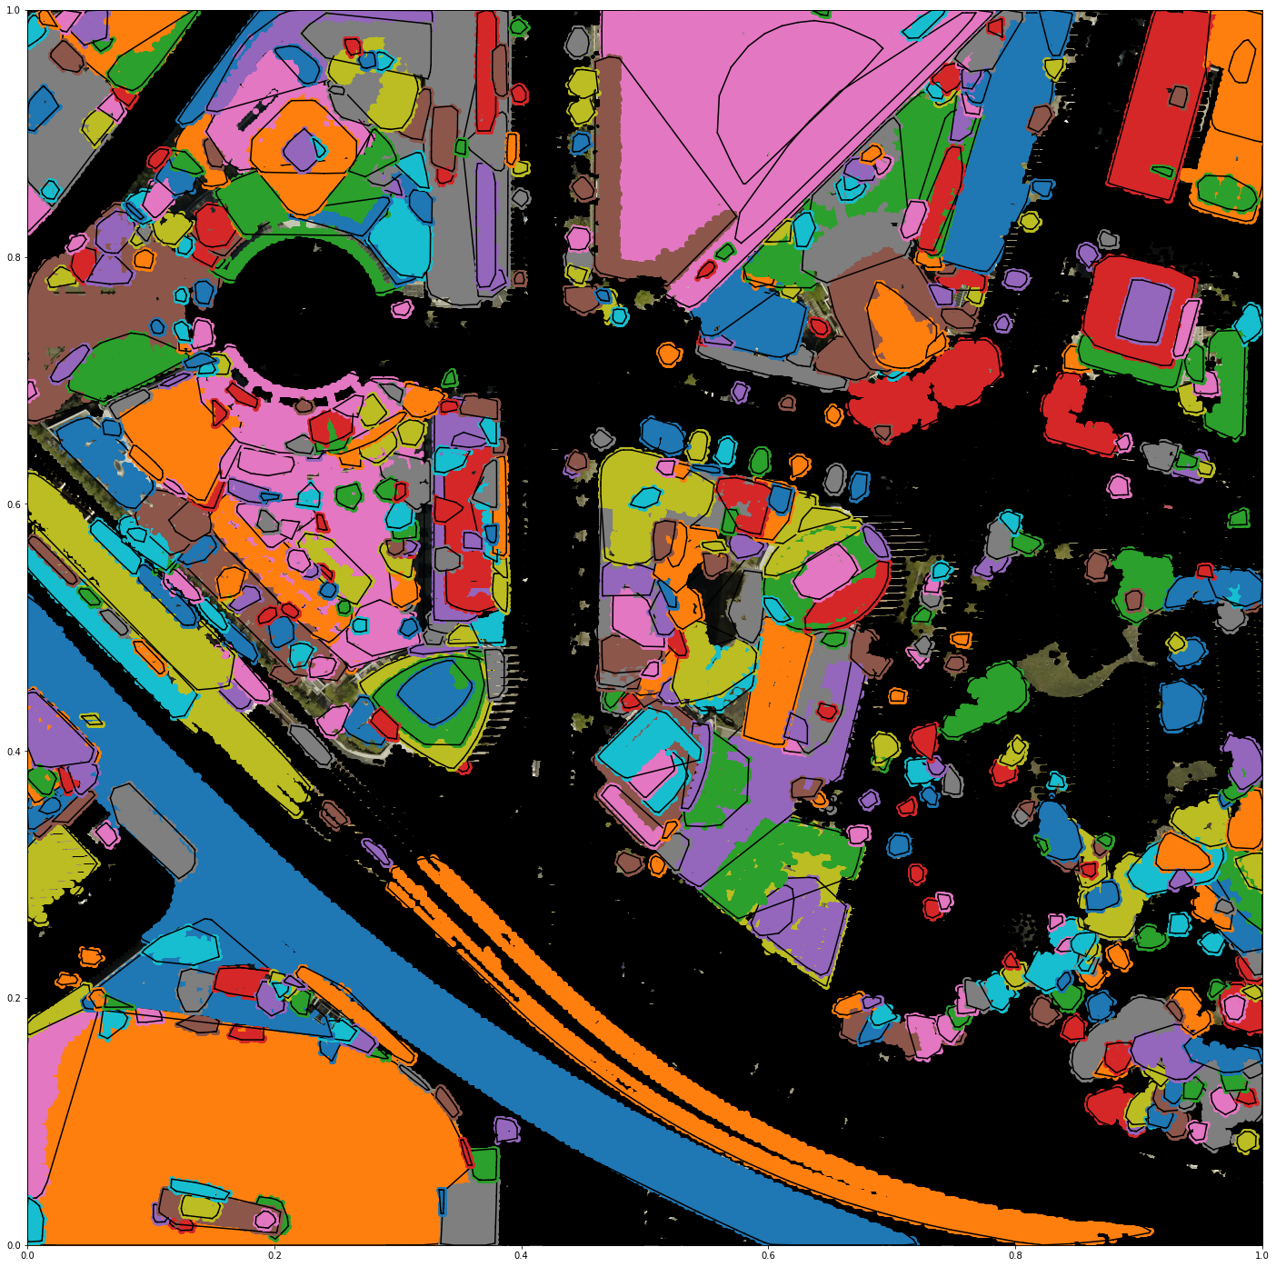

*Notable features identified*

* Large high-rise apartment buildings (potentially clustered into large sections)

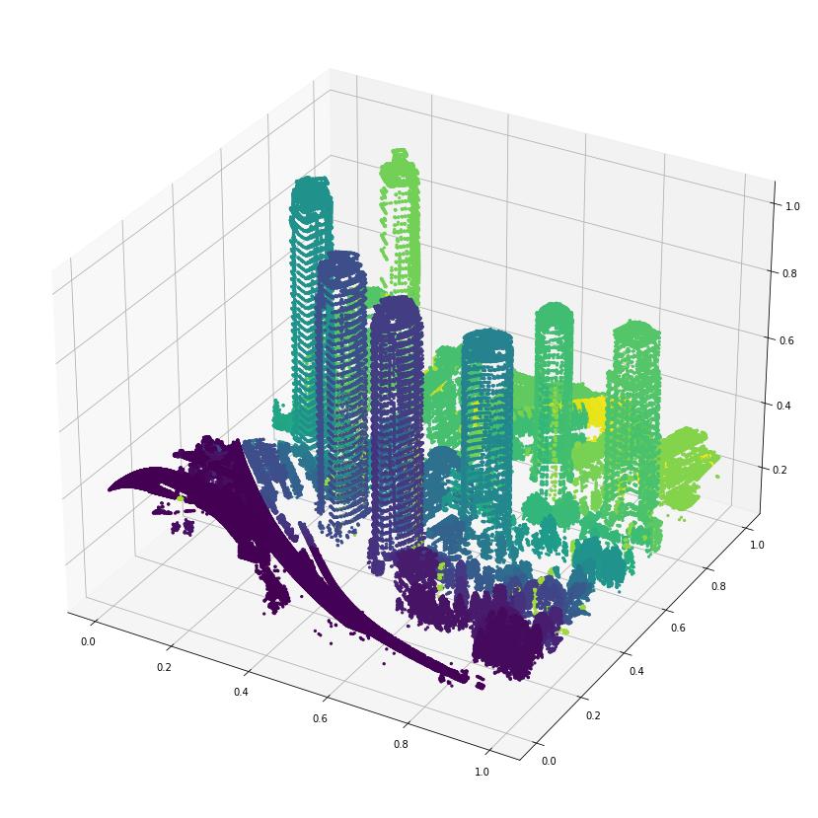

* The clock feature on one of the building was successfully differentiated from the rest of the buildings roof.

** **

* Several rows of trees were identified, along with many other trees:

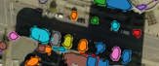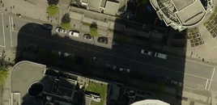 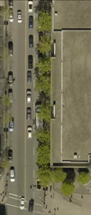 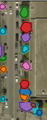

* Major landmarks/buildings and large infrastructure:

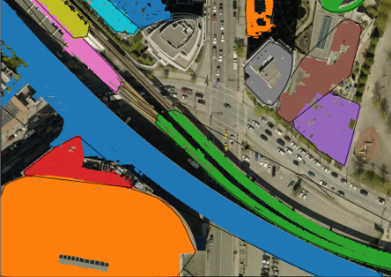 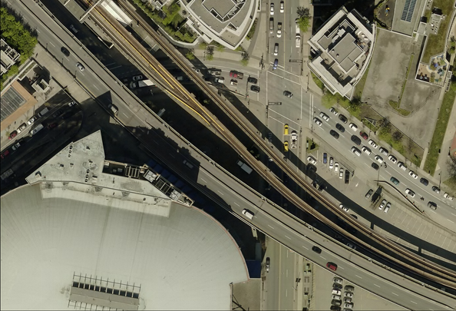

While many clusters have been identified, they are difficult to visualize all of the points, since they are in 3D. I have attempted to improve visualization of the data by exporting the data frame as a csv and importing it into ArcGIS software to view it, using the X,Y,Z coordinates and symbology applied by the db_cluster value to colour the points. These screenshots are below and provide a better view of the results.



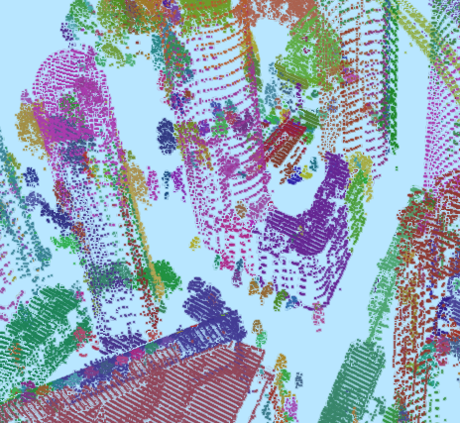

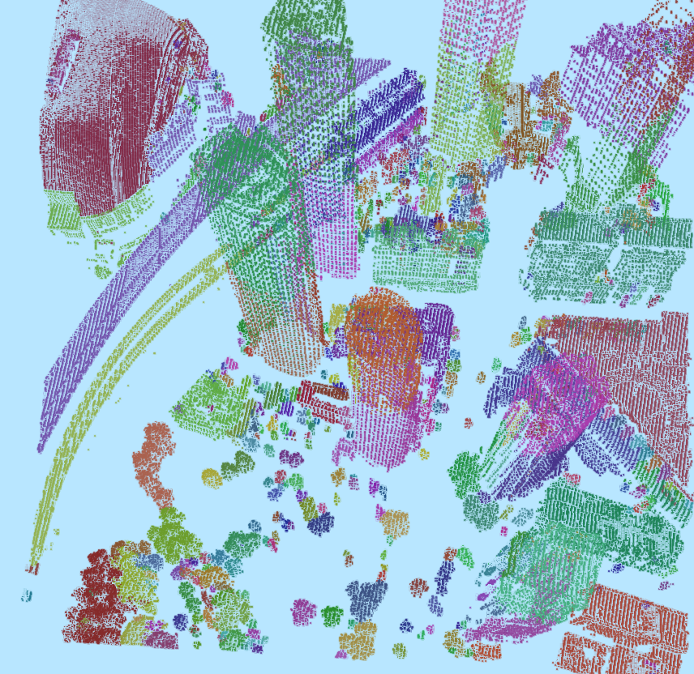

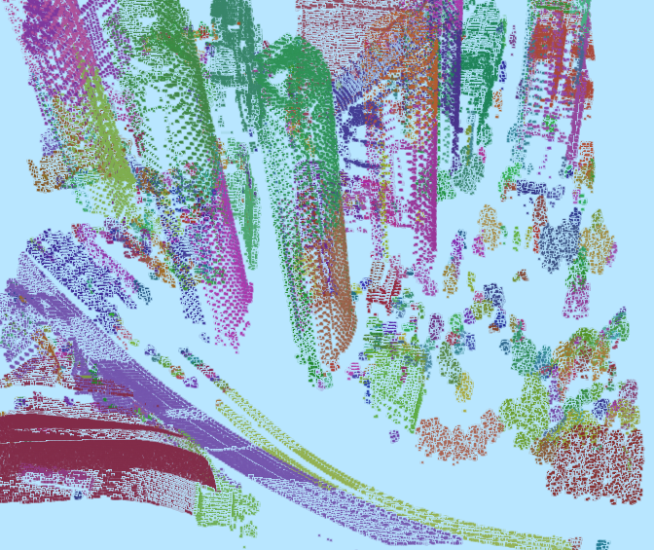

This gives a better view of the clustering performed and while it was not perfect, it generally does a good job at grouping each tree, building or other similar features together.

**Shortfalls and next steps**

Some shortfalls of this work include:

* Lack of reliable performance measures for the output and having to rely on visual references
* Shadows in the imagery: caused misclassification of points and improper clustering, seemed to work better without r,g,b although the idea seemed promising
* Difficulty to visualize all data points: since the data is in 3d, it was difficult to fully visualize the data, overhead view can only show a limited perspective.

Some next steps I would perform are:

* Label all the clusters on what they are and retrain a classifier to attempt to classify the points again
* Perform the entire process again on a new dataset using the same model to

**Summary / Conclusion**

In this project, I have attempted a method of identifying groups of points in LiDAR points that correspond to unique objects or distinguishable features in the given scene based on their surface type, height and proximity. The unsupervised clustering algorithm k-means was used to classify the points into similar groups, which were then passed into the DBSCAN algorithm along with the coordinate locations to cluster the points further into physically connected and unique features. The results prove that it can be completed to a certain reasonable success when inspected visually, though the accuracy metrics proved to not be very useful without labelled data. I also trained a supervised learning classifier to identify the ground points and was able to reclassify approx. 200,000 additional points as ground that were left unclassified when the data was provided. I believe I achieved the goal I set out to in this project and that the research question was answered sufficiently well.

# References

1. *Esrine Chehata, Li Guo, Clément Mallet.* **Airborne lidar feature selection for urban classification using random forests**. Laserscanning, Paris, France. ffhal-02384719, Sep 2009
2. *LI Yong, Wu Huayi.* **Adaptive building edge detection by combining lidar data and aerial images.** The International Archives of the Photogrammetry, Remote Sensing and Spatial Information Sciences. Vol. XXXVII. Part B1. Beijing 2008
3. *M. A. Dogon-Yaro, P. Kumara, A. Abdul Rahman, G. Buyuksalih.* **Semi-automated approach for mapping urban trees from integrated aerial lidar point cloud and digital imagery datasets**. The International Archives of the Photogrammetry, Remote Sensing and Spatial Information Sciences, Volume XLII-4/W1, 2016
4. *E. Özdemir, F. Remondino, A. Golkar.* **Aerial point cloud classification with deep learning and machine learning algorithms**. The International Archives of the Photogrammetry, Remote Sensing and Spatial Information Sciences, Volume XLII-4/W18, 2019
5. *D.L. Bool, L.C. Mabaquiao, M.E. Tupas, J.L. Fabila.* **Automated building detection using ransac from classified lidar point cloud data**. The International Archives of the Photogrammetry, Remote Sensing and Spatial Information Sciences, Volume XLII-4/W9, 2018
6. *Biswas Parajuli.* **Machine Learning Algorithms and Applications for Lidar, Images, and Unstructured Data.** Florida State University Libraries, Electronic Theses, Treatises and Dissertations. 2019
7. *Ming-Jer Huang, Shiahn-Wern Shyue, Liang-Hwei Lee, and Chih-Chung Kao.* **A Knowledge-based Approach to Urban Feature Classification Using Aerial Imagery with Lidar Data.** Photogrammetric Engineering & Remote Sensing Vol. 74, No. 12, pp. 1473–1485, December 2008
8. *Xuelian Meng, Nate Currit, Le Wang, and Xiaojun Yang.* **Detect Residential Buildings from Lidar and Aerial Photographs through Object-Oriented Land-Use Classification.** Photogrammetric Engineering & Remote Sensing Vol. 78, No. 1, pp. 35–44, January 2012
9. *Shane Grigsby.* **Spatial Clustering in Python: Processing LiDAR points into objects.** *University of California, Santa Barbara, NSERC*
10. Florent Poux. [**Discover 3D Point Cloud Processing with Python.** Towards Data Science](https://towardsdatascience.com/discover-3d-point-cloud-processing-with-python-6112d9ee38e7). April 2020